

**User Manual f or Supplier Module**

Chemical Information Management System

Department of Occupational Safety and Health Malaysia

**CONTENTS**

**USER MANUAL FOR SUPPLIER MODULE ................................................................................................... 2**

CHEMICAL INFORMATION MANAGEMENT SYSTEM ............................................................................................ 2

**MAIN SCREEN .......................................................................................................................................... 3**

**REGISTRATION ......................................................................................................................................... 4**

**LOGIN ...................................................................................................................................................... 6**

**PROFILE.................................................................................................................................................... 7**

**SUBMISSION ............................................................................................................................................ 9**

SUB MENU .............................................................................................................................................. 9

ACTIVITY BUTTON ................................................................................................................................... 10

NEW SUBMISSION .................................................................................................................................. 10

RENEWAL SUBMISSION (SUBSTANCE/MIXTURE) ............................................................................................. 19

WHEN SUBMISSION WAS ACKNOWLEDGED BY JKKP........................................................................................ 21

WHEN REJECTED BY DOSH....................................................................................................................... 22

**REPORTING ............................................................................................................................................ 23**

**Main screen**

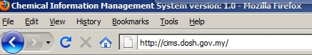

Web address: <http://cims.dosh.gov.my>

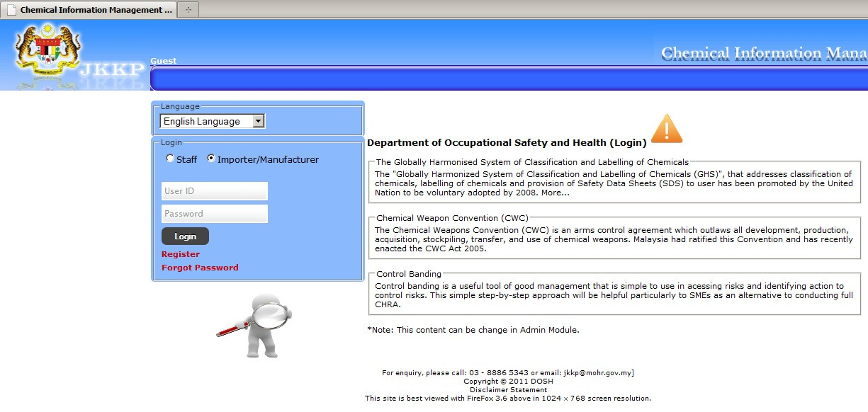

Home screen

**Registration**

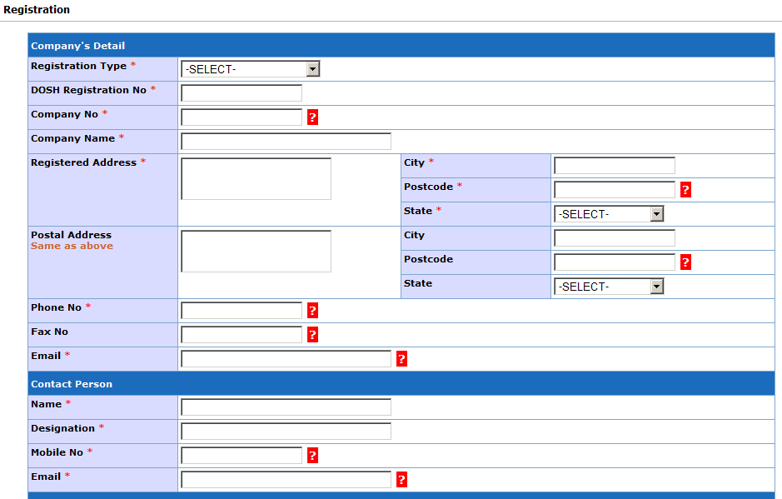

Registration form

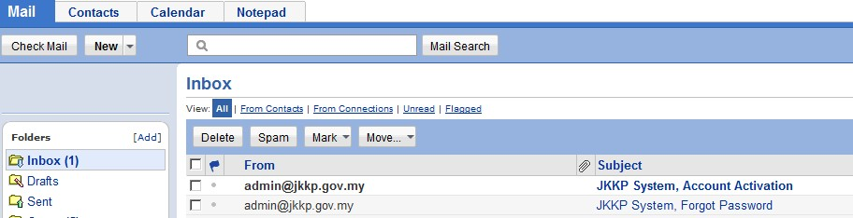

Receive notification at email.

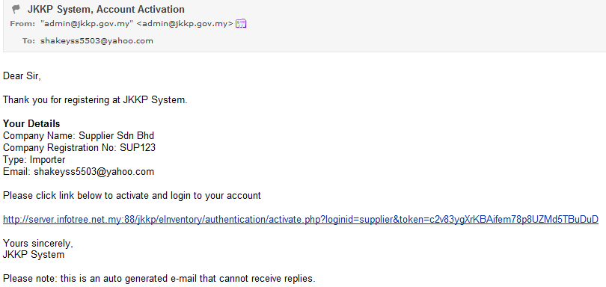

Click activation link.

Activation success

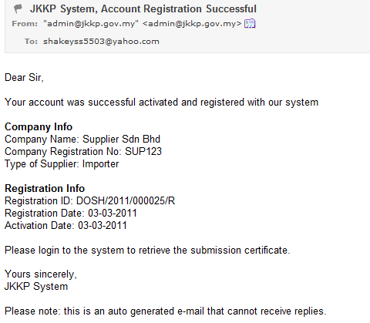

Receive email notification of successful registration.

**Login**

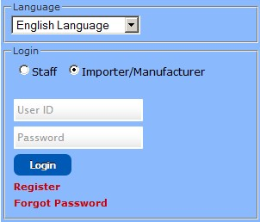

Login CIMS as Importer/Manufacturer (Supplier)

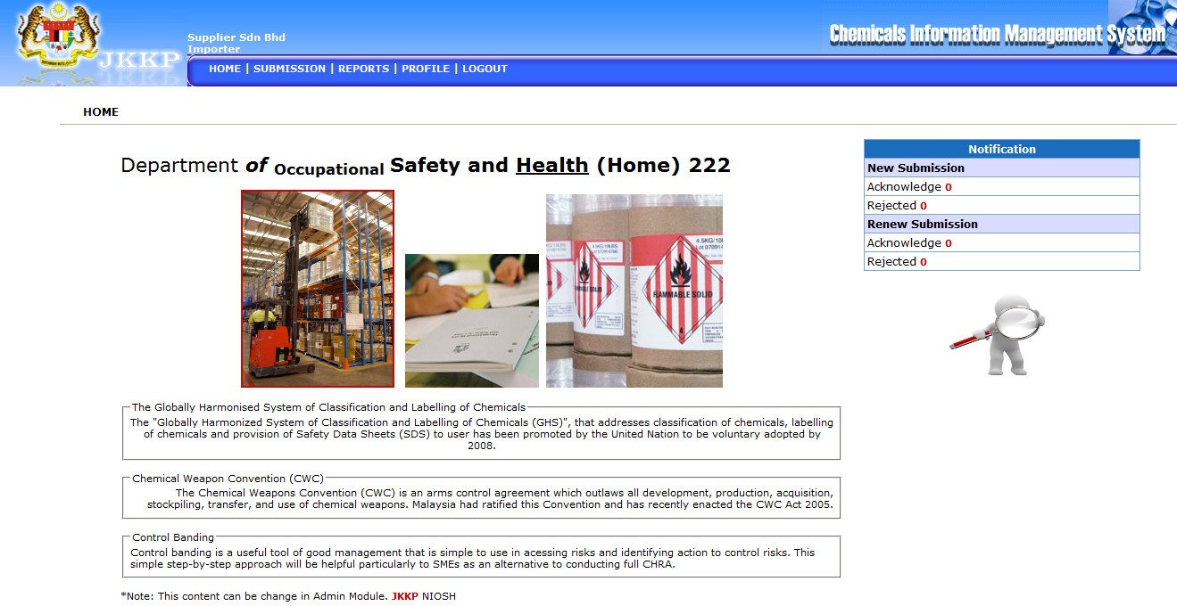

Home screen for supplier.

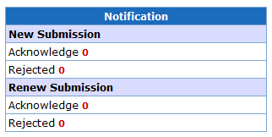

Notification shortcut for submission status.



Search chemical information.

**Profile**

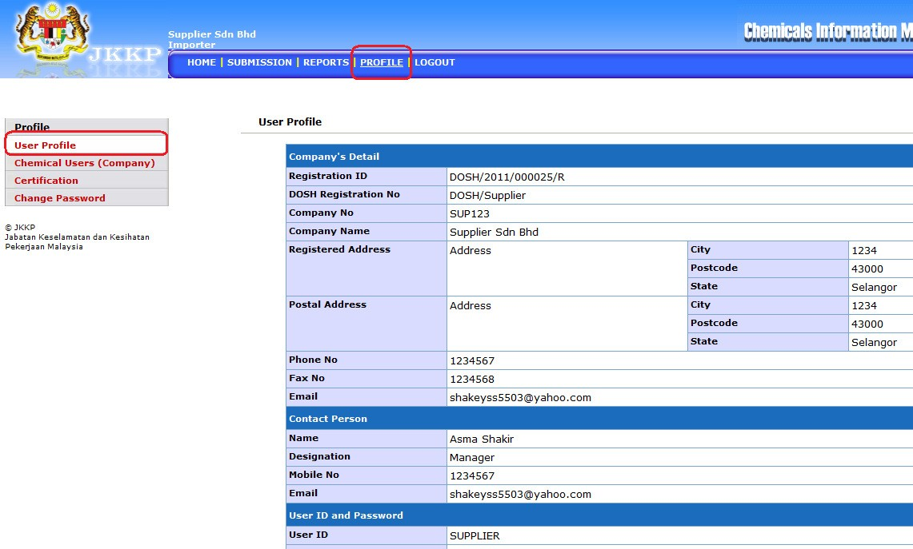

User (supplier) profile.

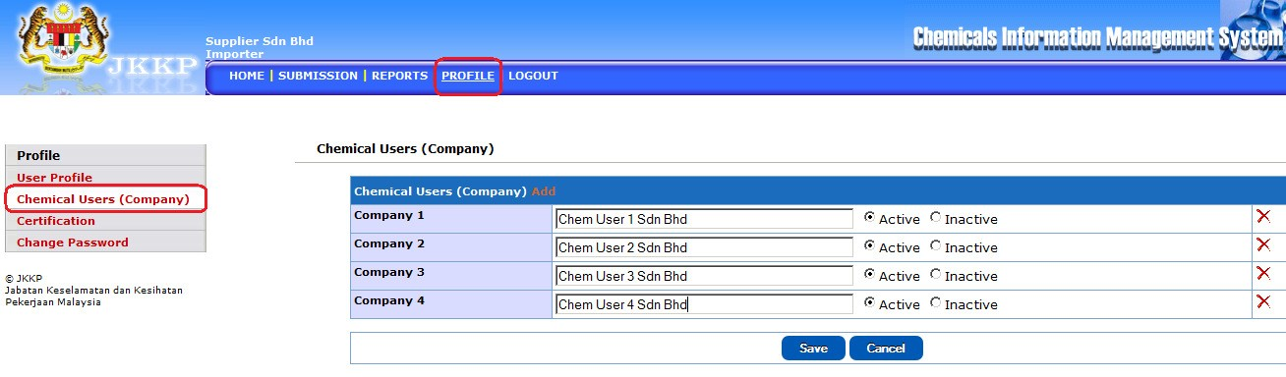

Register chemical users (company) for supplier.

View and download registration certificate.

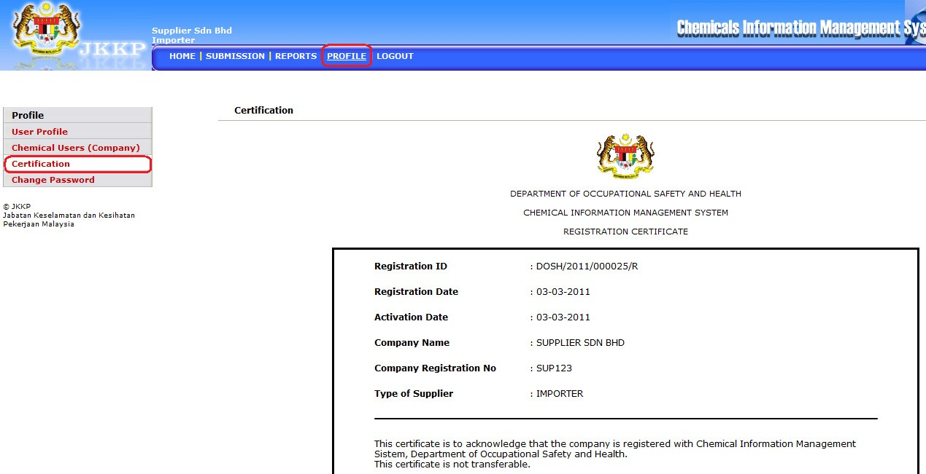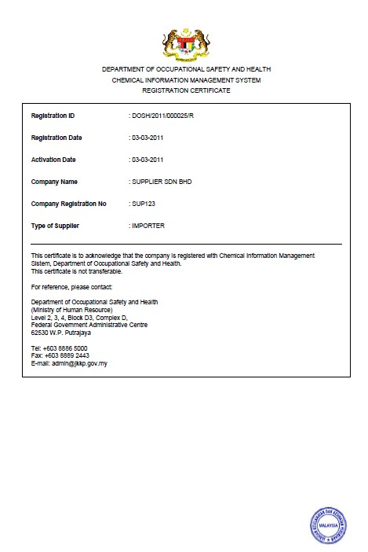

Registration certificate in PDF format.

Change password (if required)

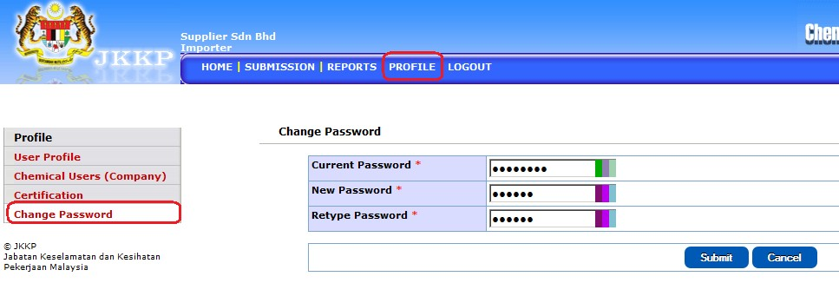

**Submission**

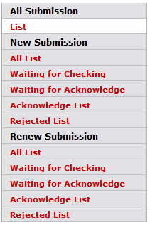

Submission sub menu

***Sub menu***

|  |  |  |
| --- | --- | --- |
| **No** | **Menu button** | **Descriptions** |
| **All Submission** | | |
| 1 | List | List all submission with status |
| **New Submission** | | |
| 2 | All List | List all new submission only with status |
| 3 | Waiting for Checking | List new submission which is waiting for checking |
| 4 | Waiting for Acknowledge | List new submission which is waiting for acknowledge |
| 5 | Acknowledge List | List all acknowledge submission |
| 6 | Rejected List | List all rejected submission |
| **Renewal Submission** | | |
| 7 | All List | List all renewal submission only with status |
| 8 | Waiting for Checking | List renewal submission which is waiting for checking |
| 9 | Waiting for Acknowledge | List renewal submission which is waiting for acknowledge |
| 10 | Acknowledge List | List all acknowledge submission |
| 11 | Rejected List | List all rejected submission |

Menu descriptions

***Activity Button***



|  |  |  |
| --- | --- | --- |
| **No** | **Button** | **Descriptions** |
| 1 |  | View record details |
| 2 |  | Edit record |
| 3 |  | Download certificate registration/acknowledge submission |
| 4 |  | Renew submission |

***New Submission***

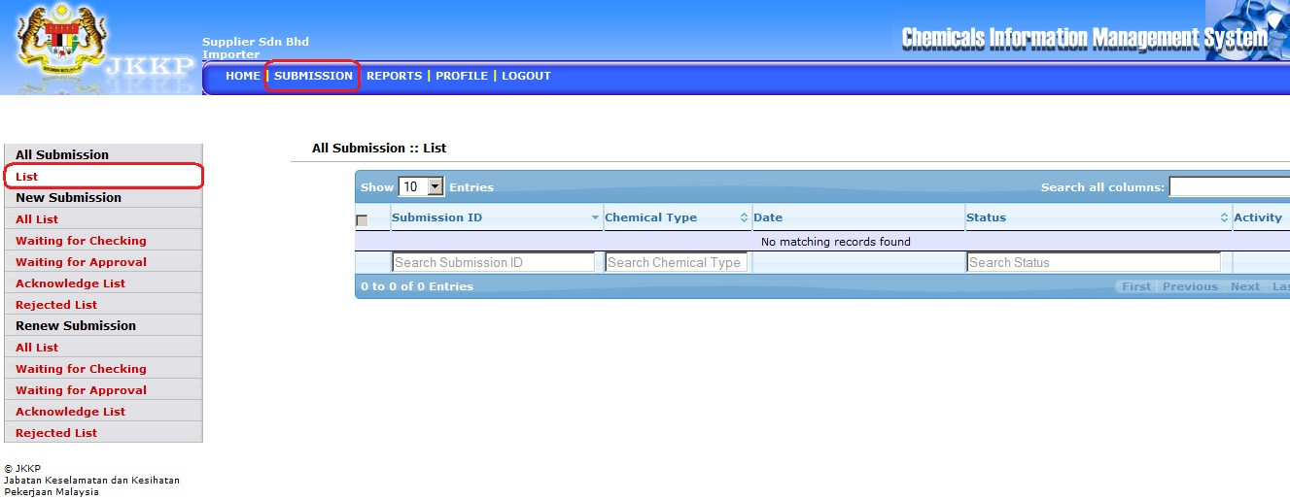

New submission screen.

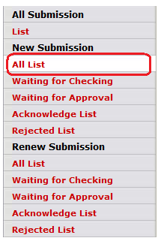

View all list for new submission



Add new submission

**1. Substance**

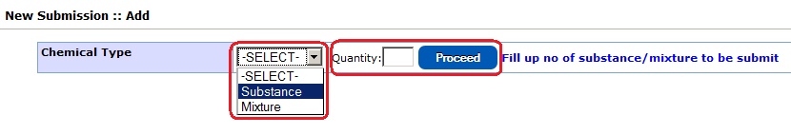

Select chemical type and no of chemical to be submit.



Fill up form and click on Proceed button

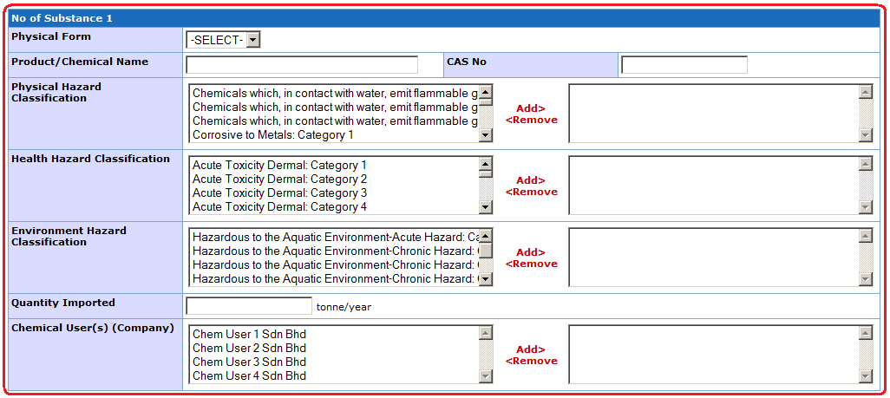

Fill up substance informations.



Click on Product/Chemical name.

Select chemical or search from the list.

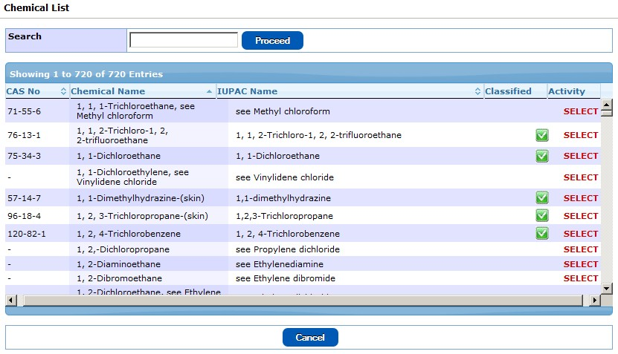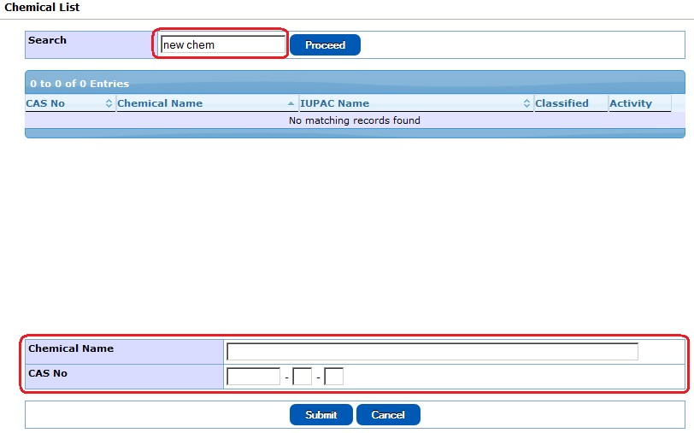

If new chemical, fill up Chemical Name and CAS No.

Fill up form accordingly and click Save button.

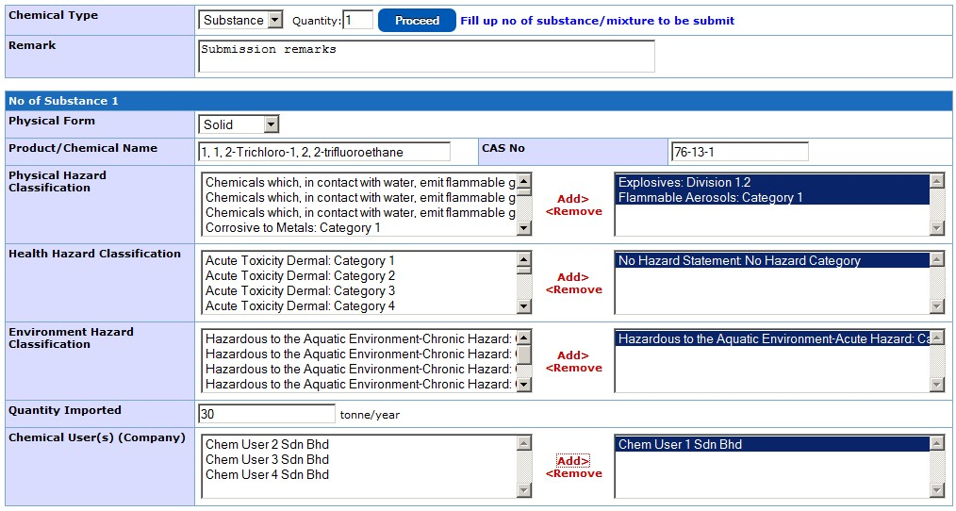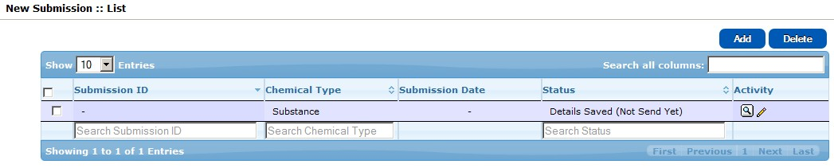

Chemical submission was saved in the system but not submit yet. Click Edit to



confirm submission.

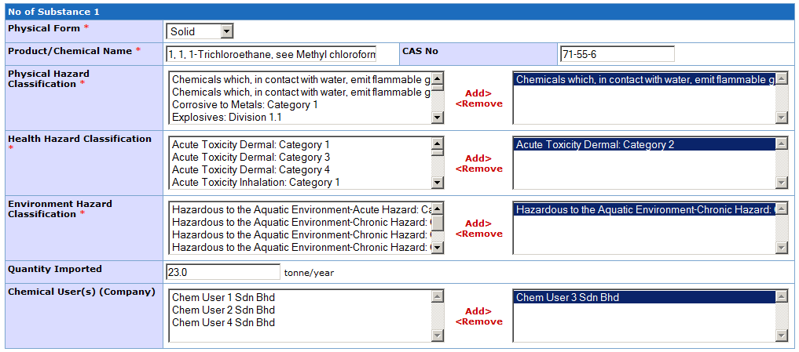

Click Save & Submit button to submit chemical information to DOSH for acknowledgement.

Tick ( √ ) on terms and conditions form. Click Save & Submit button the complete. Submission was sent to DOSH for acknowledgement.

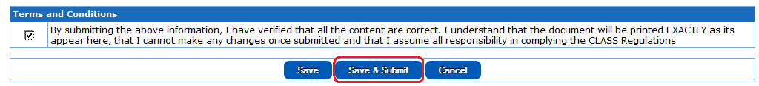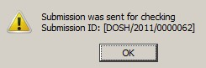

System will prompt for successful submission. Receive submission ID automatically.

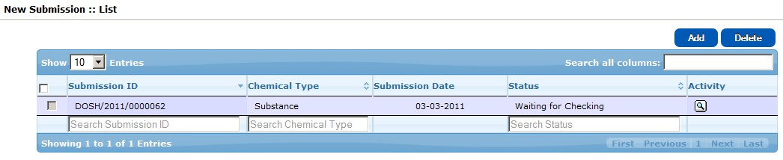

New submission list show submission status.

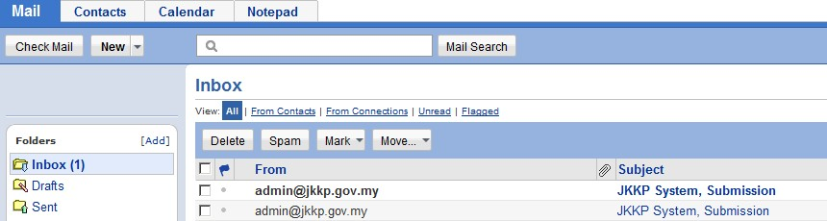

System automatically prompt user email for successful new submission

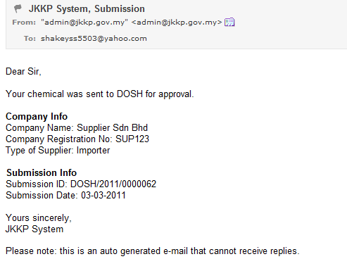

Email from system to user.

**2. Mixture**

Select chemical Type and no of chemical to be submit.

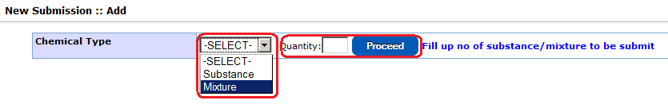

Fill up form accordingly.

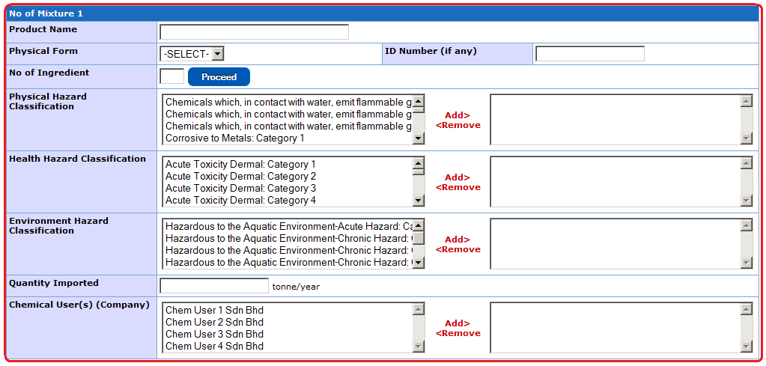

Mixture submission form

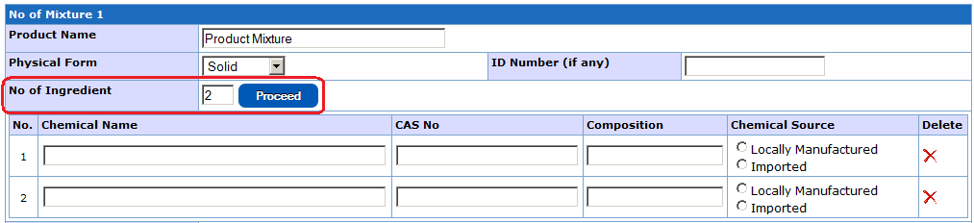

Fill up No of Ingredient for mixture.

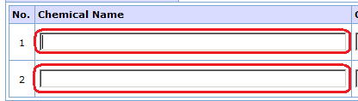

Click Chemical Name text box.

Select or search chemical from list.



If new chemical, fill up Chemical Name and CAS No. Click Submit.

Fill up chemical information accordingly and click Save button.

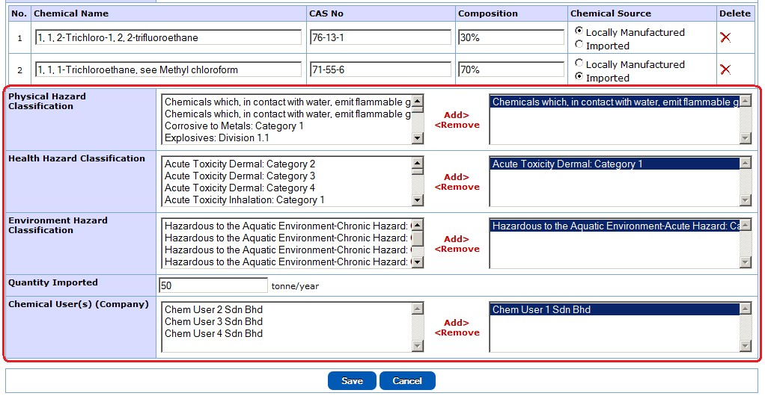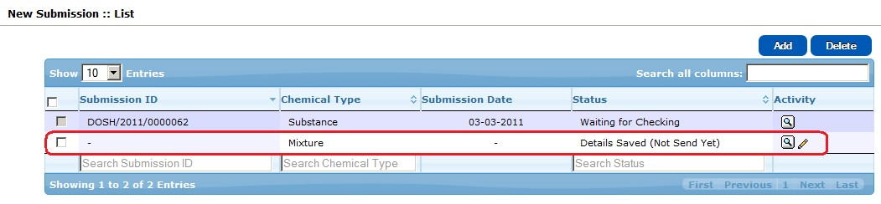

New submission for mixture was saved to the system. Click Edit button to confirm chemical information.

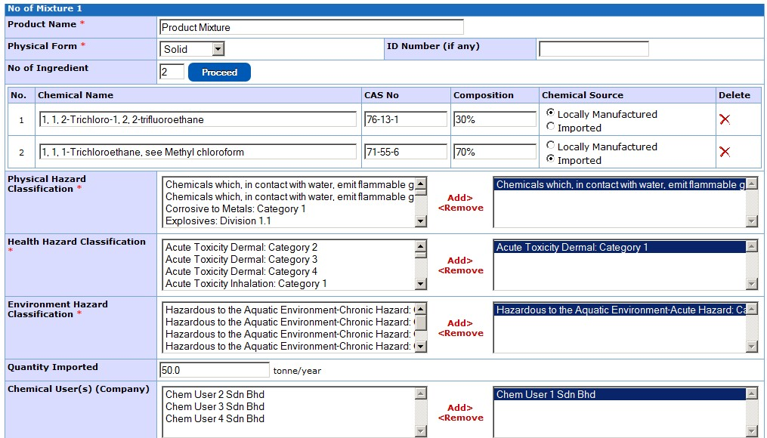

Confirm the chemical information.

Tick ( √ ) on terms and conditions form. Click Save & Submit button the complete. Submission was sent to DOSH for acknowledgement.

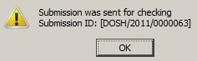

System prompt user for successful submission and receive Submission ID.

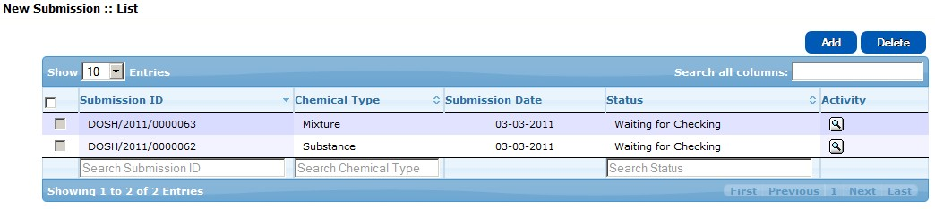

New submission will appear in the New Submission List.



User receive notification at email for new submission.

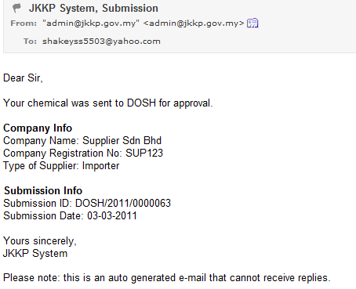

Email from system to user.

***Renewal Submission (Substance/Mixture)***

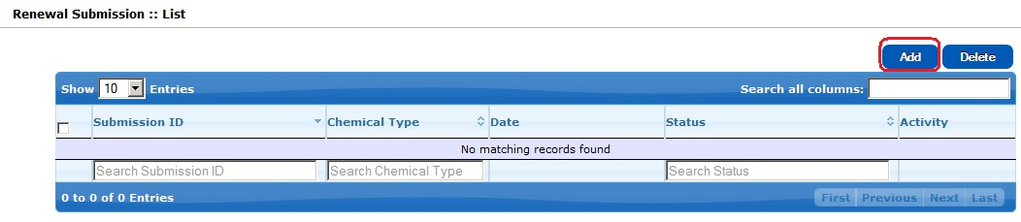

Click Add button from Renewal Submission List.

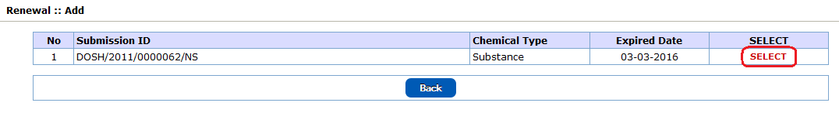

Select submission from the list.

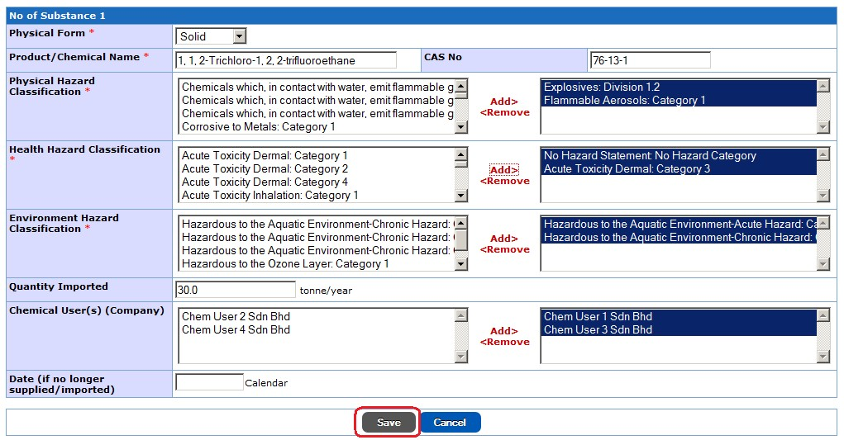

Confirm chemical information and click Save button

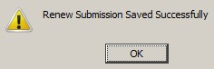

System prompt user for successful submission.

Renewal submission include in Renewal Submission List. Click Edit button to confirm chemical details information.

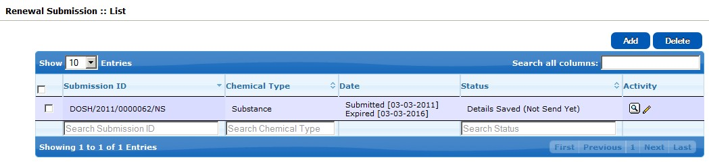

Tick ( √ ) on terms and conditions form. Click Save & Submit button the complete. Submission was sent to DOSH for acknowledgement.

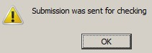

System prompt user for successful submission.

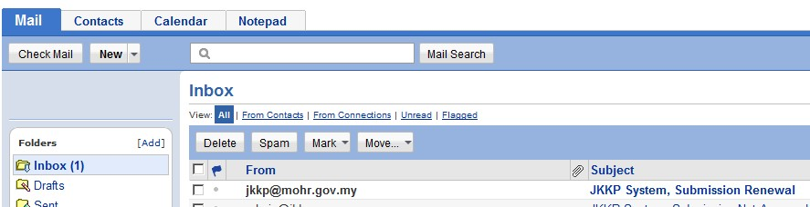

Receive email for Submission Renewal.

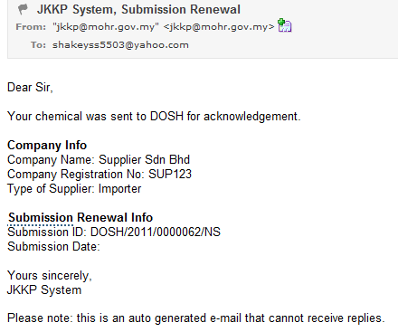

Renewal submission email from system

***When Submission was Acknowledged by JKKP***

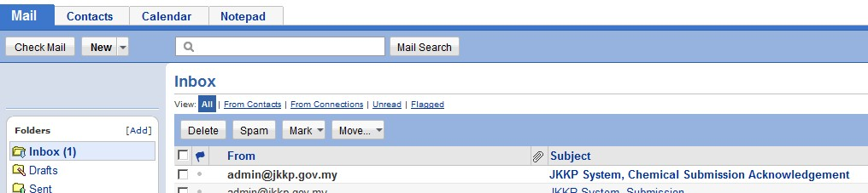

Receive email from system.

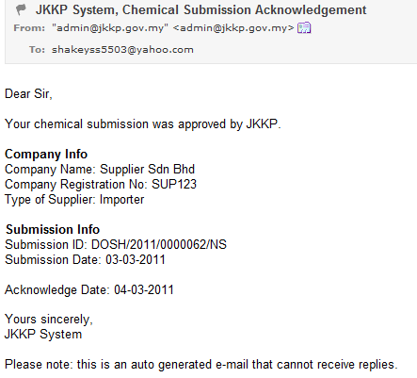

Email from system.

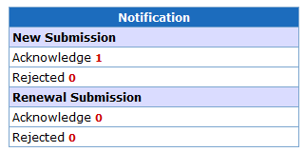

Notification box at Home screen will show status.

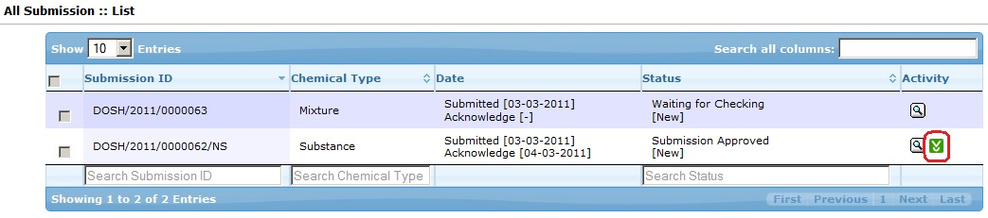

Click Download button to download Acknowledgement Certificate.



***When Rejected by DOSH***

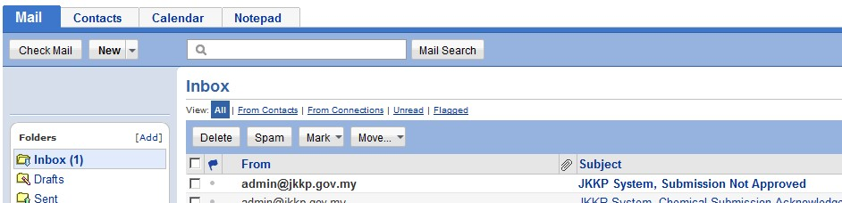

Received email from system.

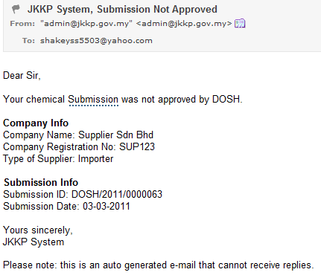

Email from system.

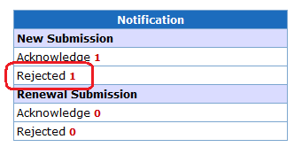

Notification box at Home screen will show status.

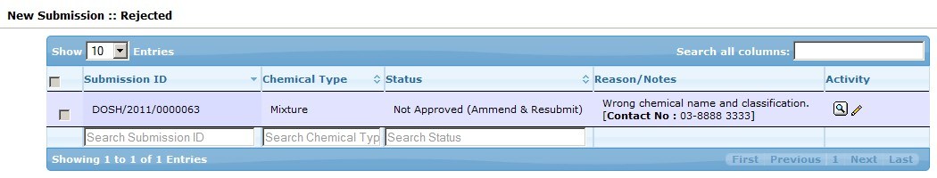

Rejected submission will appear in Rejected List.

**Reporting**

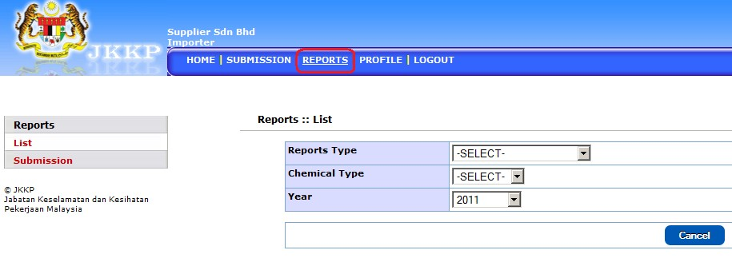

Reports screen

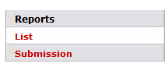

Reports for List of Acknowledged submission.

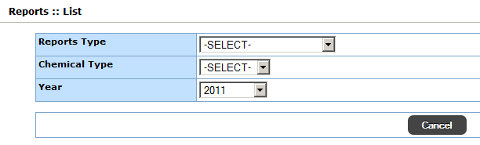

Select report type, chemical type and year. Click Submit button when complete.

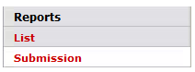

Reports for Submission details

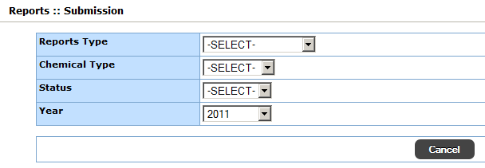

Select report type, chemical type, status and year. Click Submit button when complete.